Course2

* KNN
* Linear Regression – OLS

Ridge (L2 penalty)

Lasso (L1 penalty) -> sparse model

* Logistic Regression
* Cross validation
  + Stratified cross validation: The Stratified Cross-validation means that when splitting the data, the proportions of classes in each fold are made as close as possible to the actual proportions of the classes in the overall data set as shown here.
* Decision tree

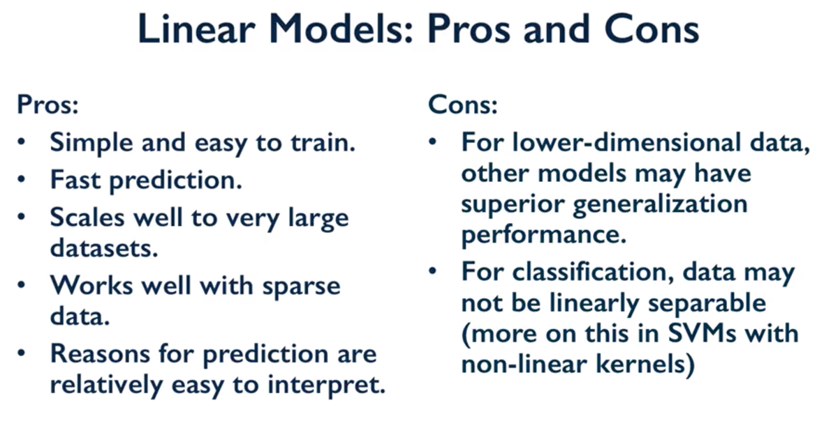

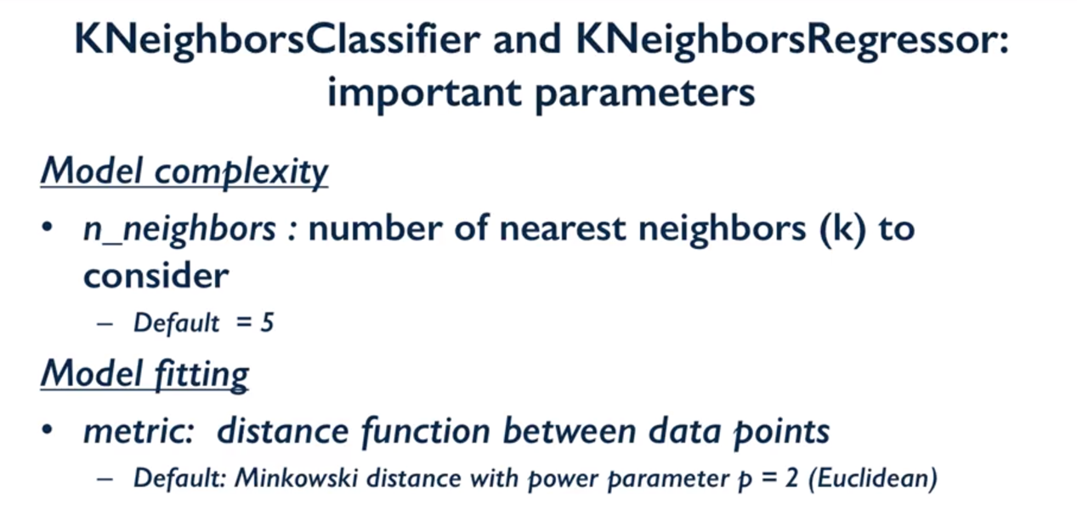

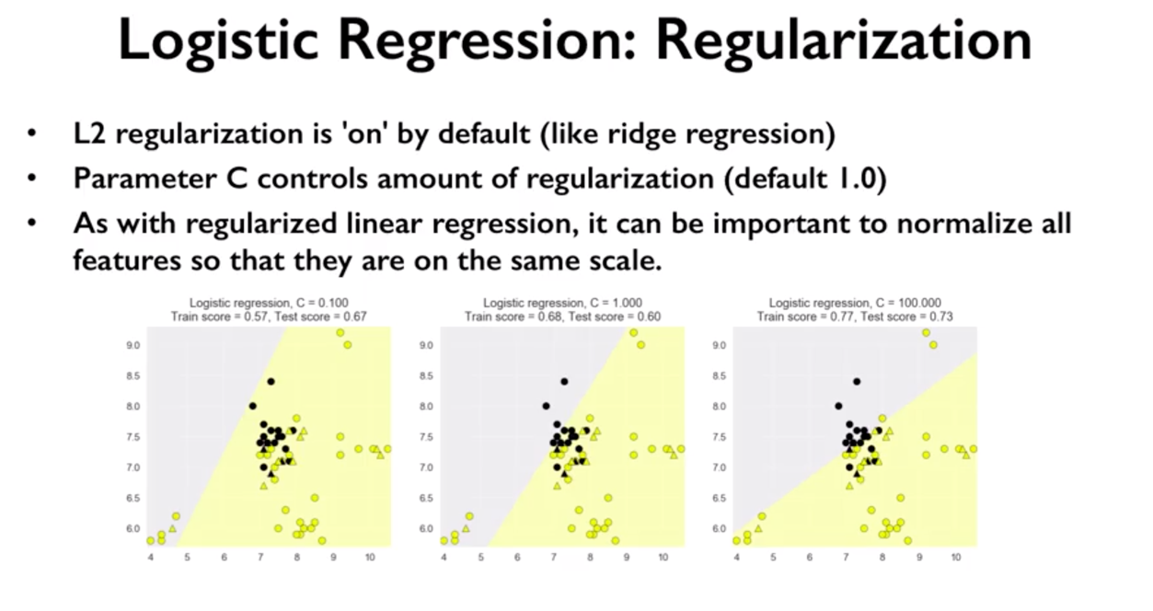

* For L1 and L2 regularization
  + If alpha is larger -> meaning the model will be more simple since the coefficient will towards to zero for ridge regression and exactly zero for lasso

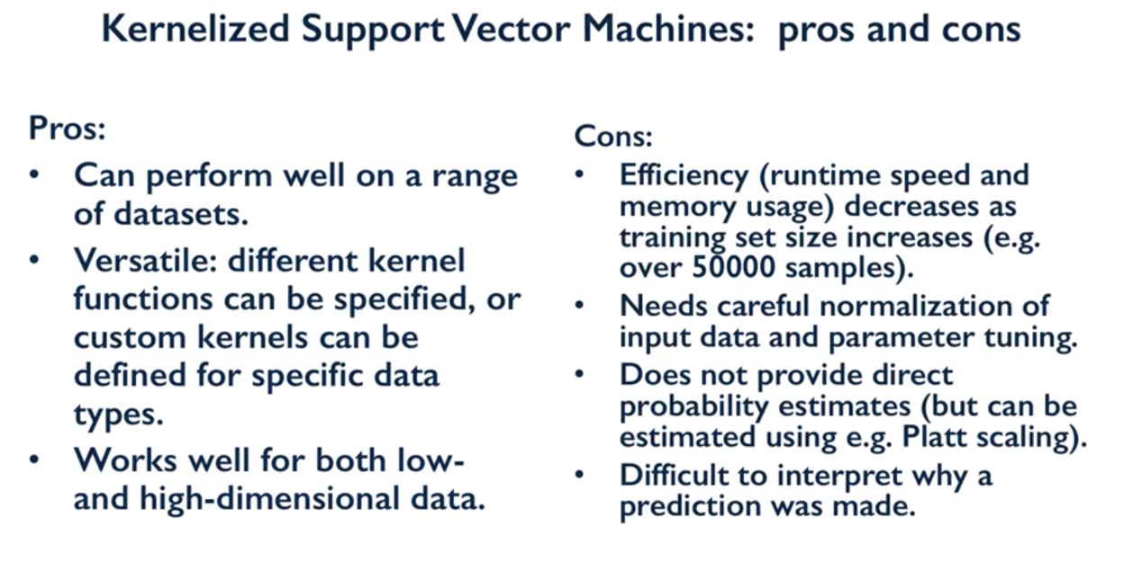

* C& gamma parameter for kernel SVM
  + low C and gamma -> the model will be more simple

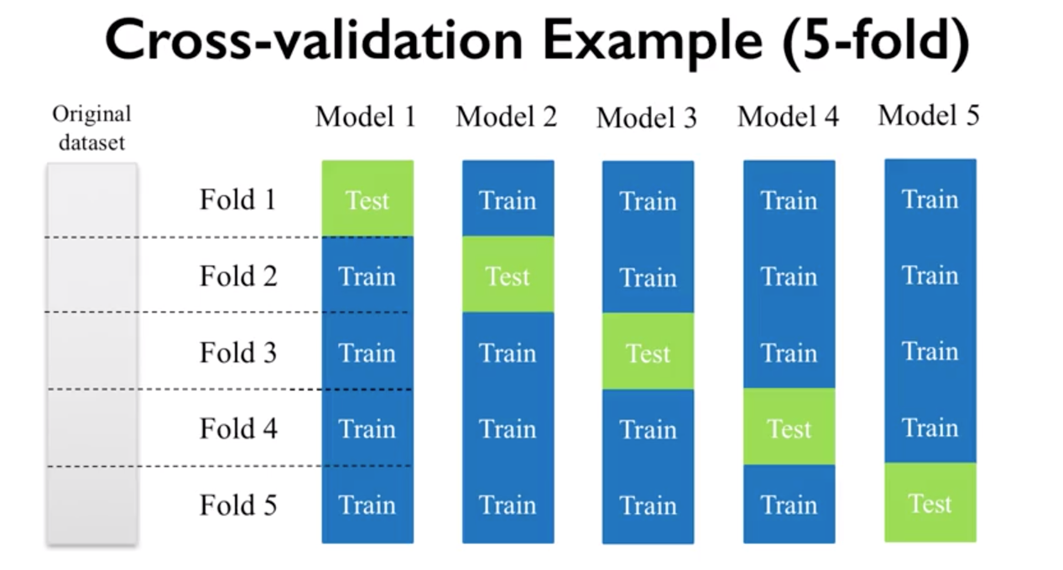

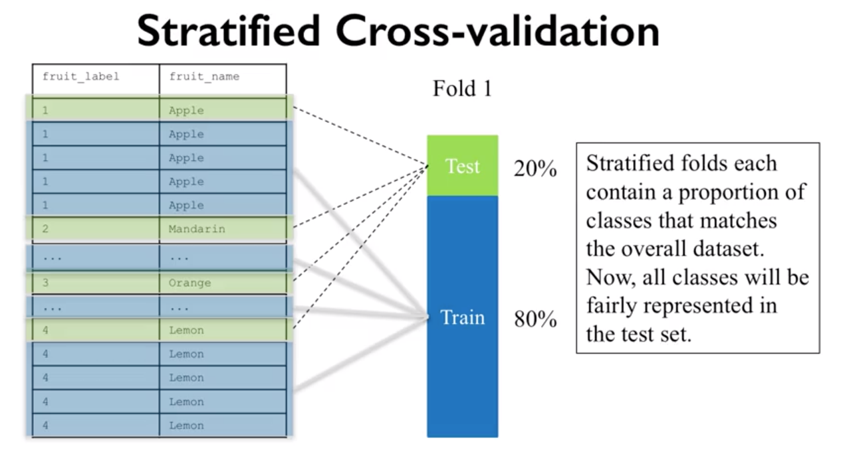

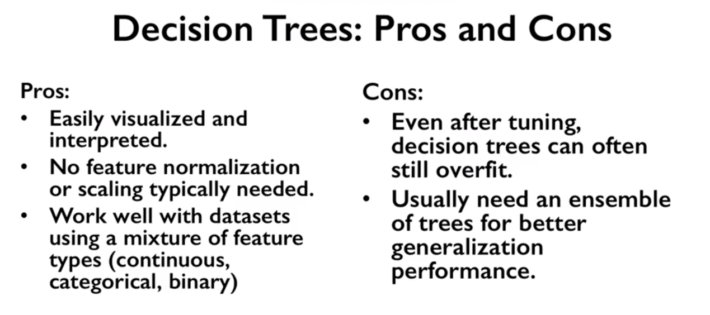

Course 3

* Model evaluation
  + Dummy classifier

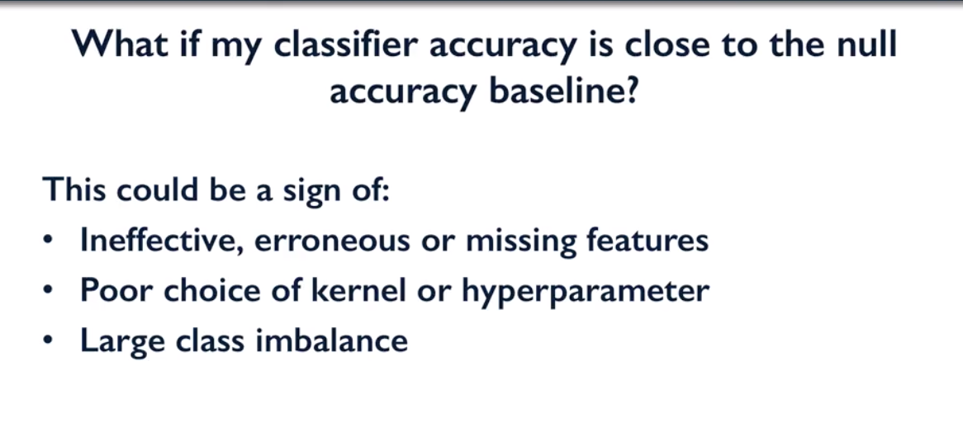

* Confusion matrix
* Precision, Recall, ROC curve
  + Trade-off between Precision(TP/TP+FP) and Recall(TP/TP+FN)
    - Recall oriented: tumor detection, legal discovery
    - Precision oriented: search engine ranking, query suggestion, customer facing
    - F1 score = 2*Precision*Recall/(precision+recall)

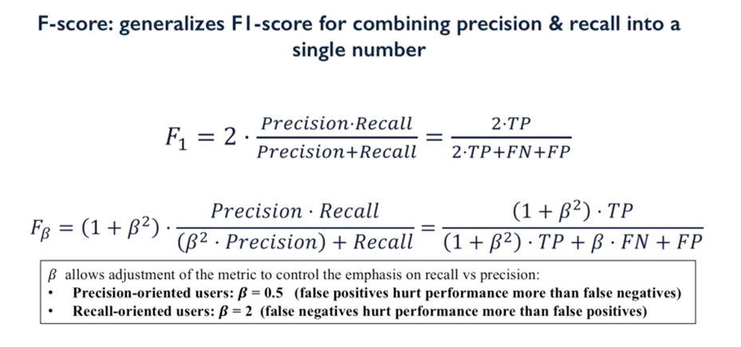

* + 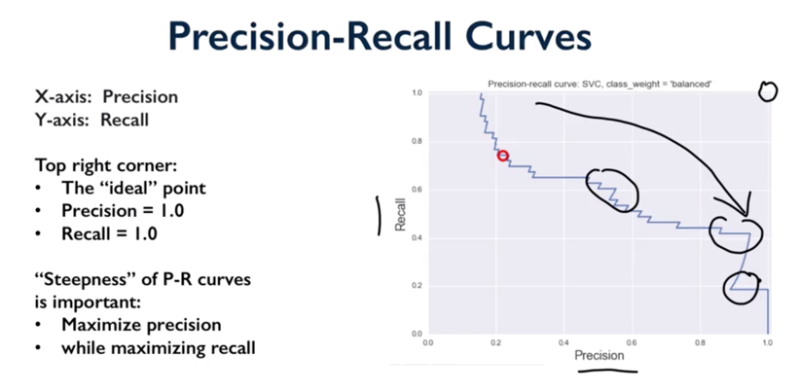

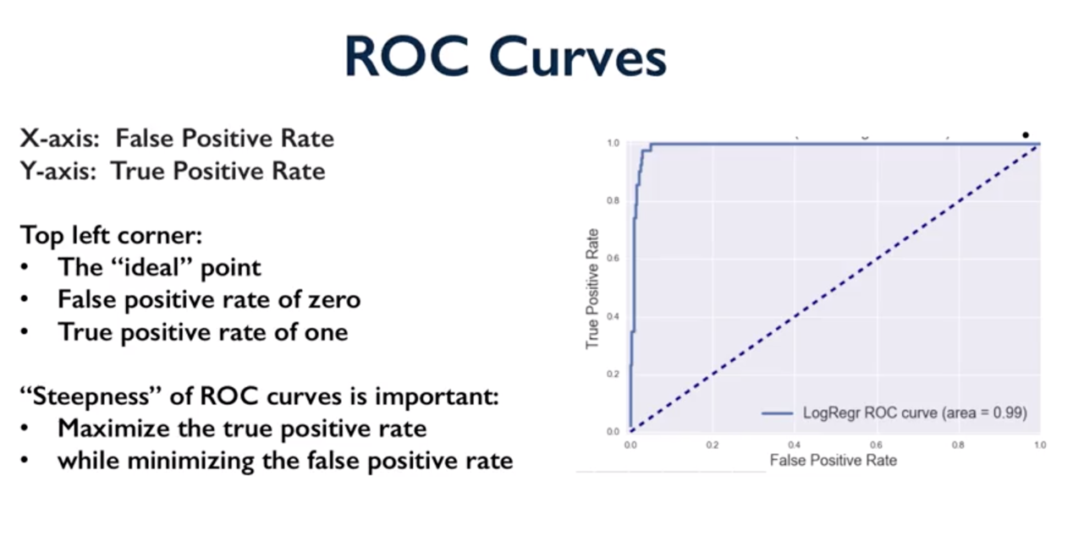

* Multi-class evaluation
  + Confusion matrix
* Regression evaluation
* Model Selection

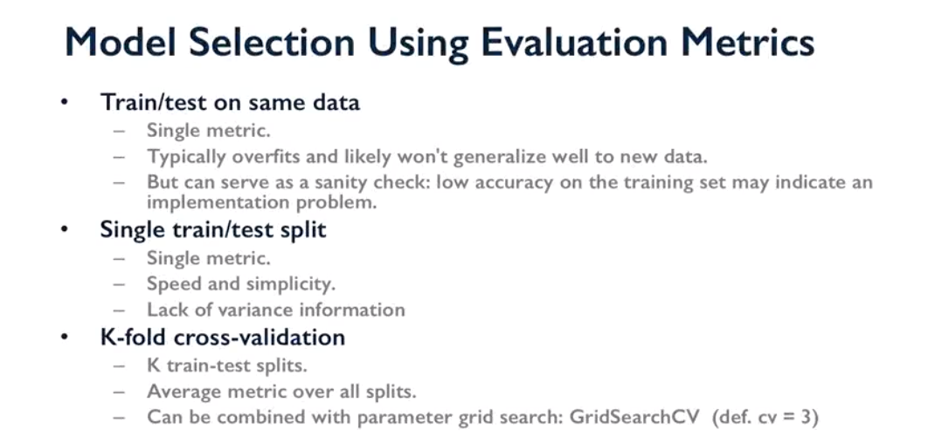

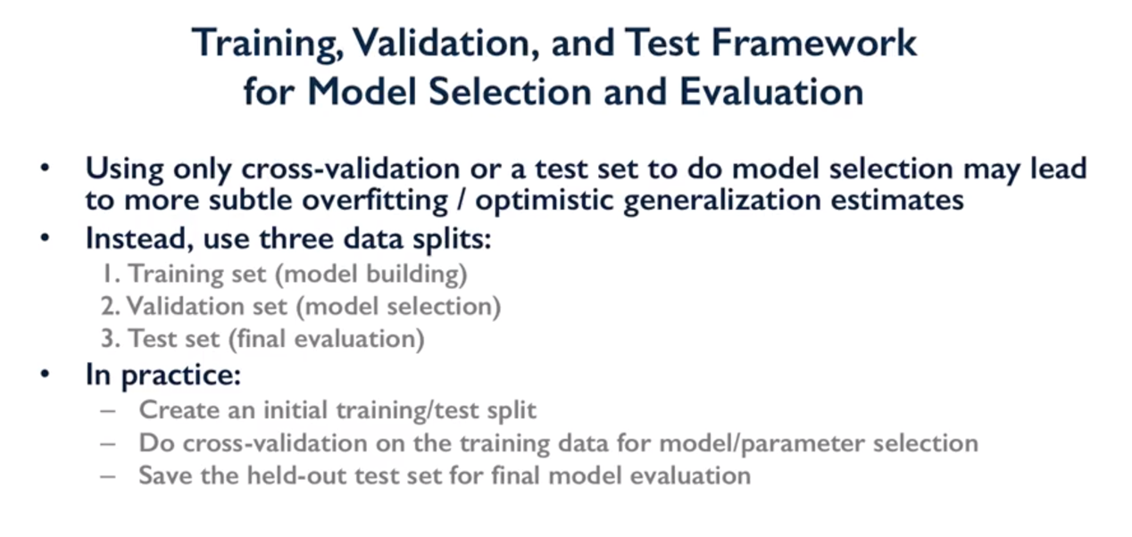

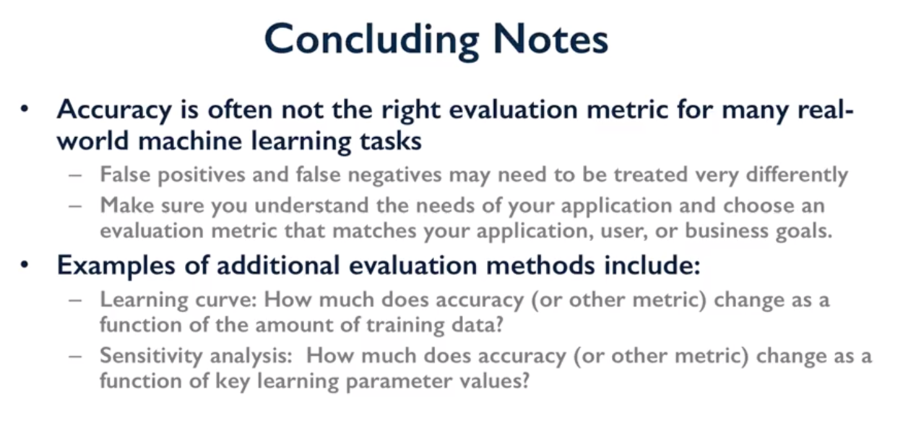

Course 4

* Naïve Bayes classifier
* Random forest (ensemble learning)
* Gradient Boosted Decision Trees
* Neural Network
* Deep learning summary

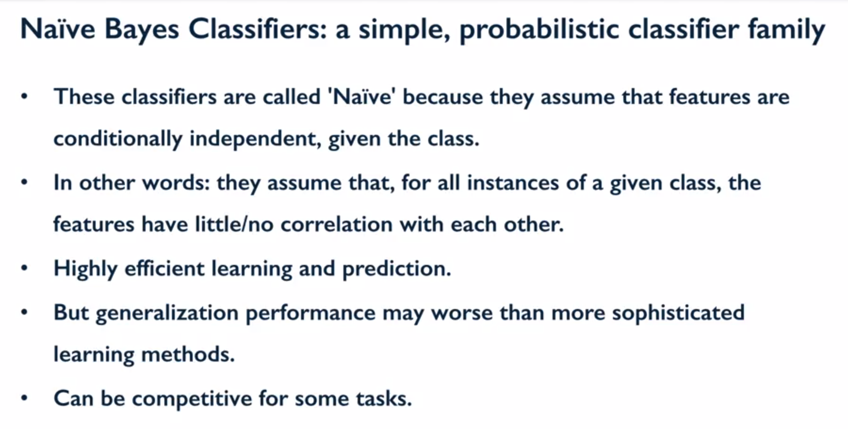

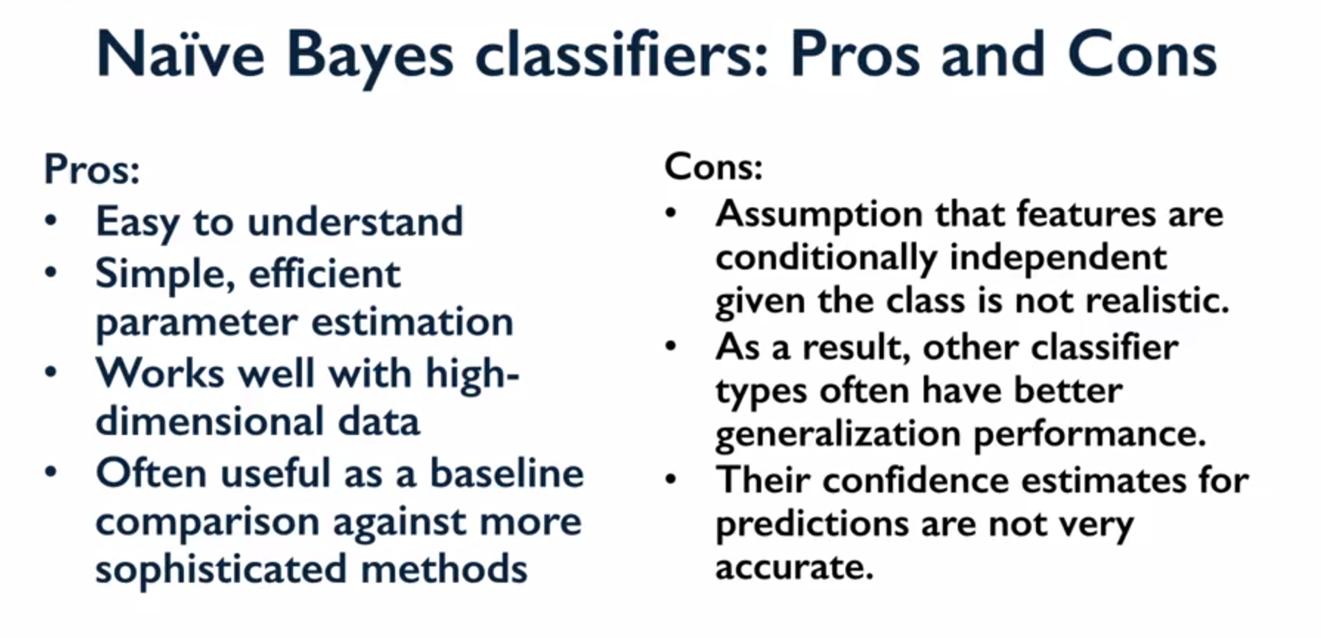

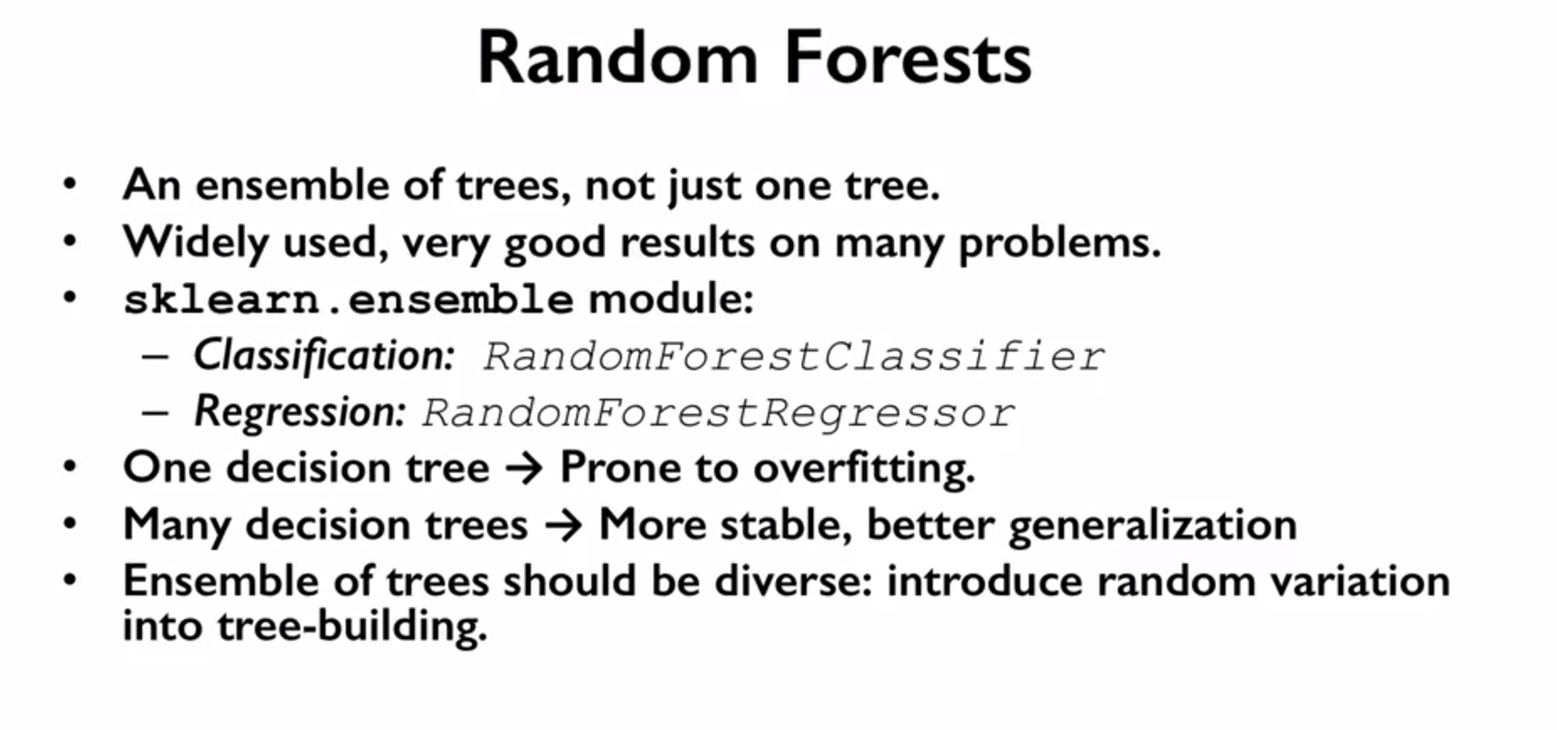

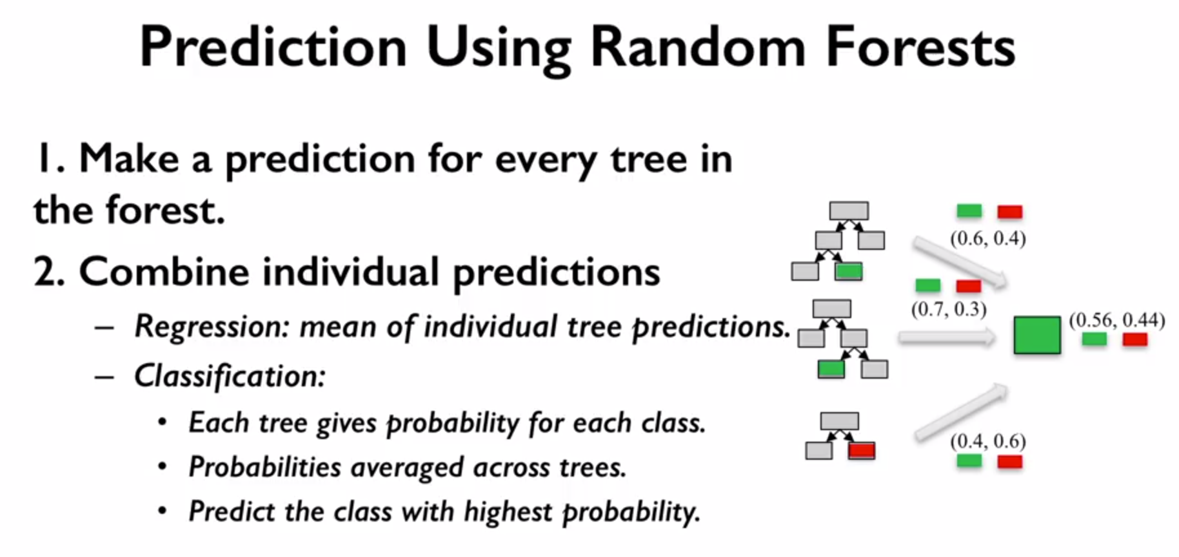

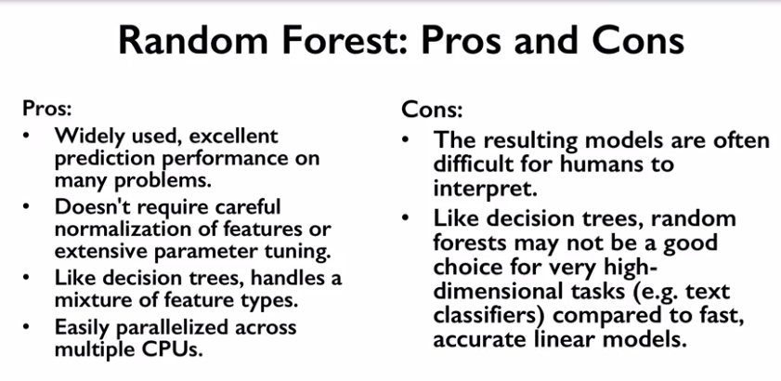

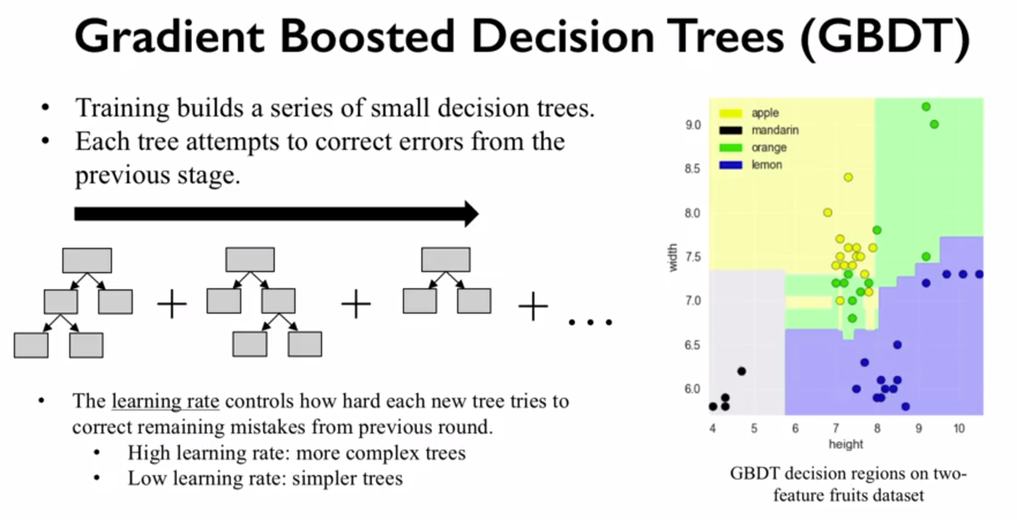

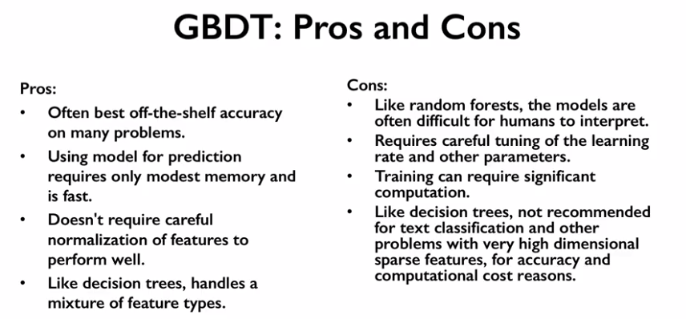

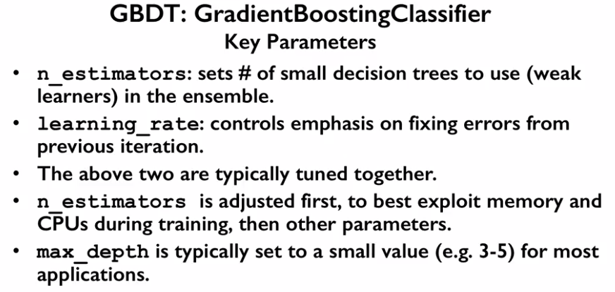

**Neural network – MLP**

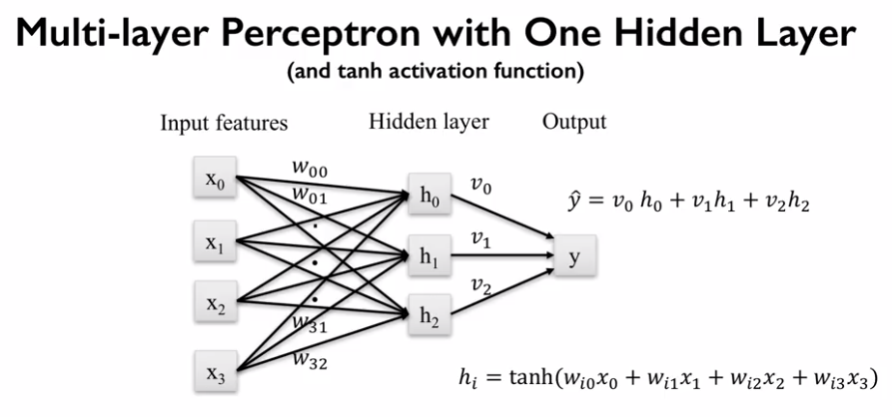

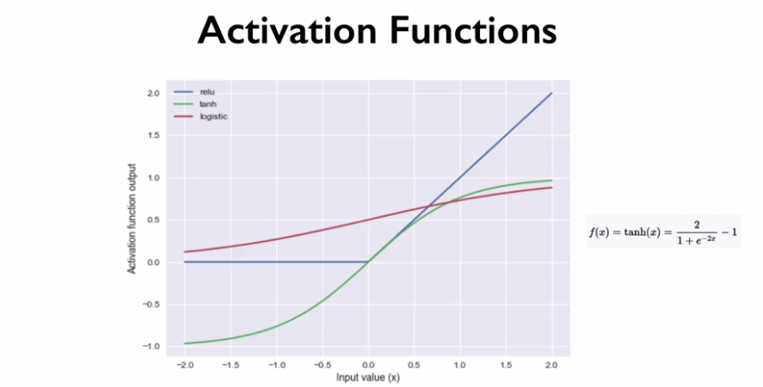

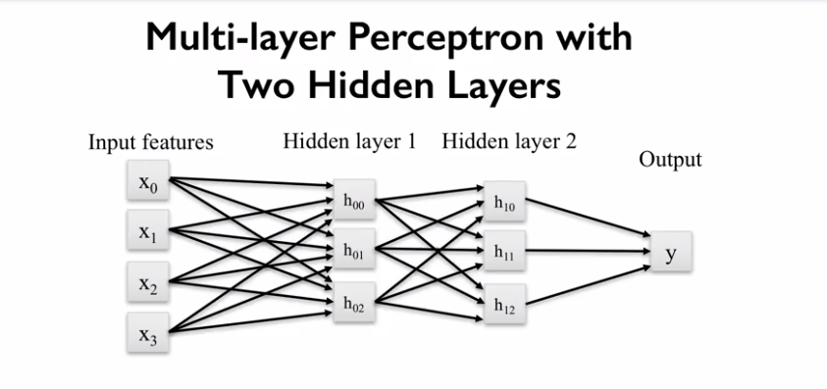

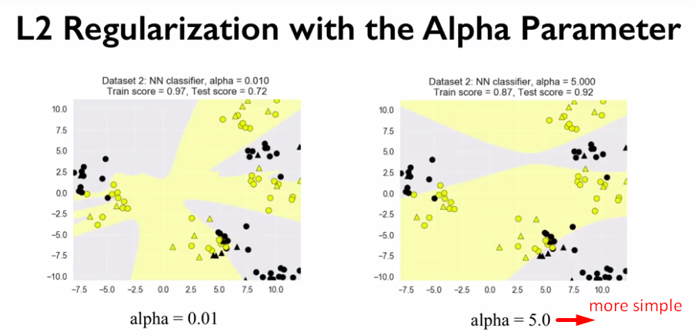

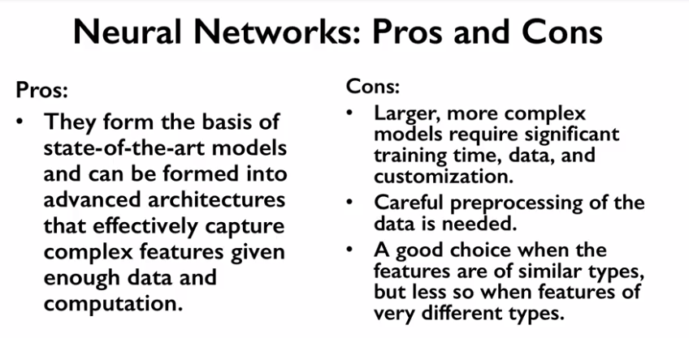

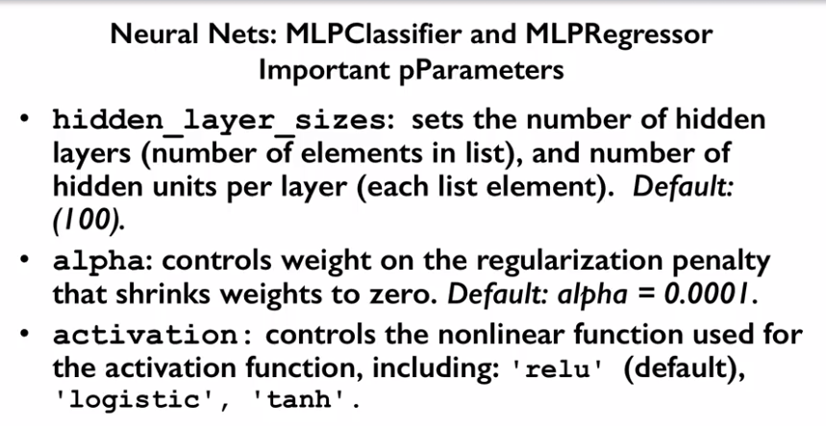

neural network simulation

[http://playground.tensorflow.org/#activation=tanh&batchSize=10&dataset=circle&regDataset=reg-plane&learningRate=0.03&regularizationRate=0&noise=0&networkShape=4,2&seed=0.75913&showTestData=false&discretize=false&percTrainData=50&x=true&y=true&xTimesY=false&xSquared=false&ySquared=false&cosX=false&sinX=false&cosY=false&sinY=false&collectStats=false&problem=classification&initZero=false&hideText=false](http://playground.tensorflow.org/#activation=tanh&batchSize=10&dataset=circle&regDataset=reg-plane&learningRate=0.03&regularizationRate=0&noise=0&networkShape=4,2&seed=0.75913&showTestData=false&discretize=false&percTrainData=50&x=true&y=true&xTimesY=false&xSquared=false&ySquared=false&co)

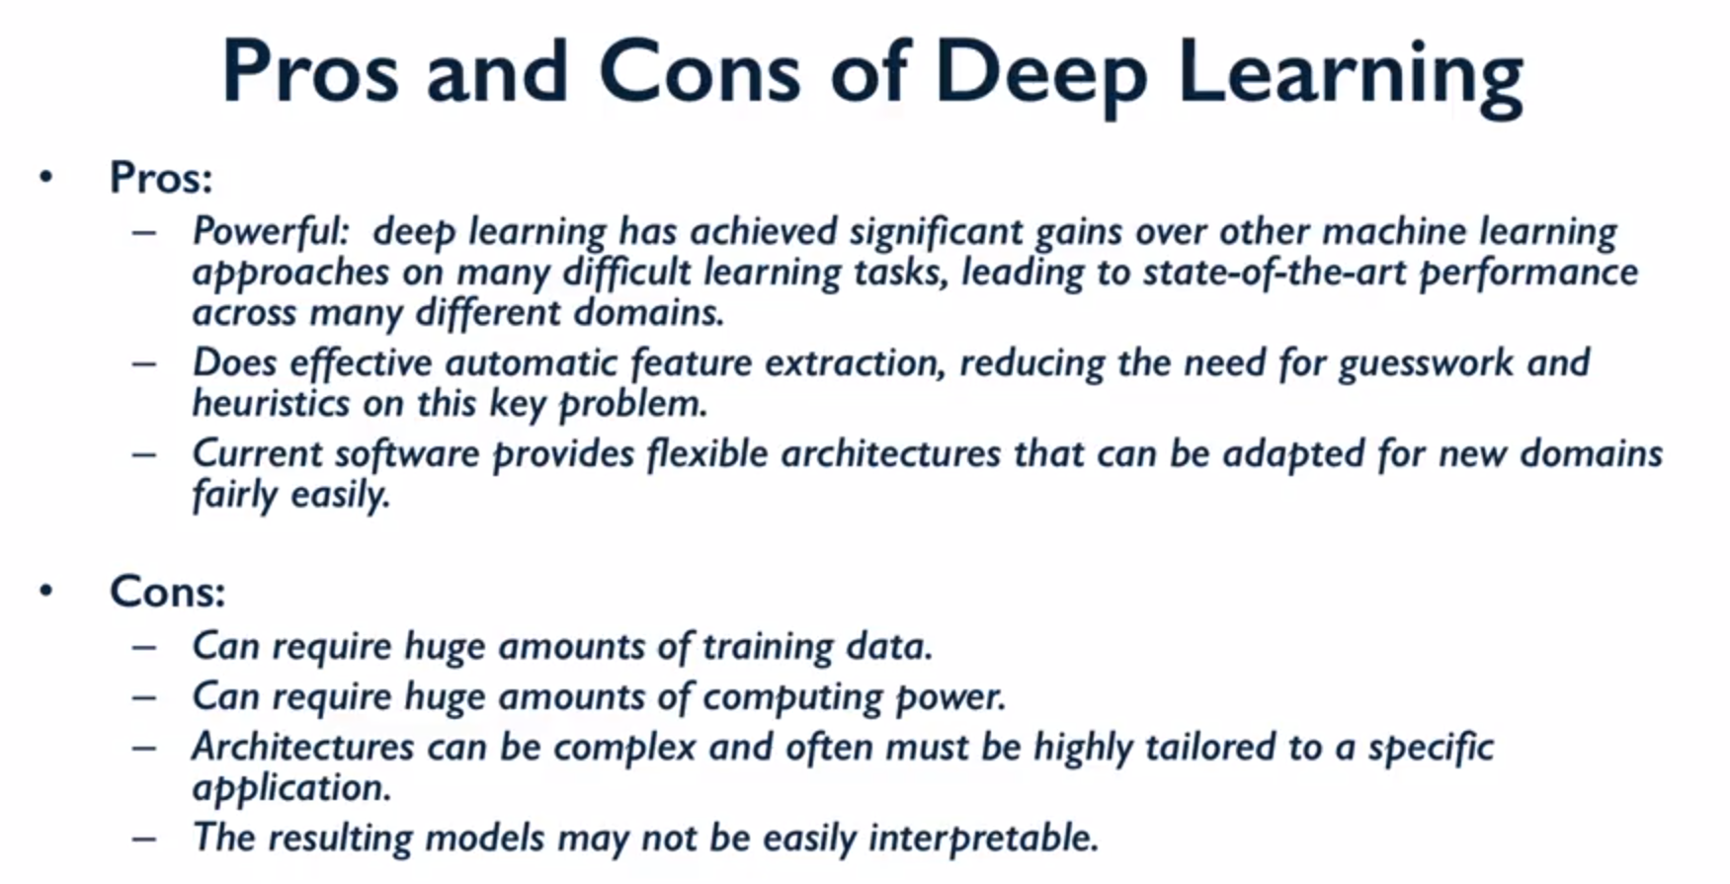

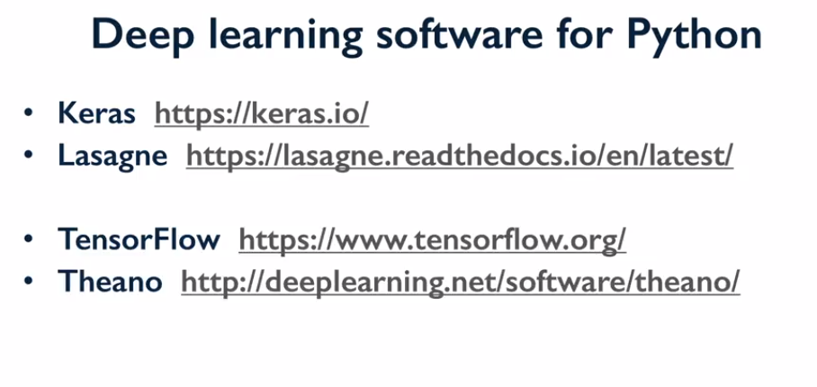

Deep learning articles:

<https://devblogs.nvidia.com/deep-learning-nutshell-core-concepts/>

